Technical report
for
OPD-HMS
Prepared by AF-WE03

Group members
Registration number | Name
IT15135230 | A.A.B.S.Amarathunga
IT15110244 | J.H.N.S.Keerthirathna
IT15107206 | S.A.G.A.Suraweera
IT15117410 | S.P.U.K.Weerasinghe

Table of Contents
Table of Contents ii
1. Introduction 1
1.1 Purpose 1
1.2 Document Conventions 1
1.3 Intended Audience and Reading Suggestions 1
1.4 Product Scope 1
1.5 Reference 2
2. Overall Description 2
2.1 Product Perspective 2
2.2 Product Functions 2
2.3 User Classes and Characteristics 3
2.4 Operating Environment 3
2.5 Design and Implementation Constraints 3
2.6 User Documentation 4
2.7 Assumptions and Dependencies 4
3. External Interface Requirements 4
3.1 User Interfaces 4
3.2 Hardware Interfaces 6
3.3 Software Interfaces 6
3.4 Communications Interfaces 6
4. System Features 7
4.1 Use case Diagram 7
4.2 Activity Diagram 8
4.3 Use case Scenarios 9
4.4 Rest Web Services 13
5. Other Nonfunctional Requirements 17
5.1 Performance Requirements 17
5.2 Software Quality Attributes 17
Appendix A: Analysis Models 18
• High level Architecture 18

Introduction

Purpose
The main purpose of our system is to make hospital outpatient department’s tasks easy and to develop software that replaces the manual opd system into automated hospital management system. This document serves as the unambiguous guide for the developers of this software system.

Document Conventions
This document has a standard format with font “Times New Roman” , font size 18 and bold for the main topics, font size 14 and bold for the sub topics and all other descriptions will be in font size 12 without bold with 1.5 line spacing. If a main topic has sub topics it will numbered as number 1 for main topic and sub topic has number 1.1 and so on.

Intended Audience and Reading Suggestions
Project team with the objective to refer and analyze the information, especially developers of the team. This document can be used in any case regarding the requirements of the project and the solutions that have been taken. Finally, the document would provide a clear idea about the system to be built.

Product Scope
The proposed software is called OPD (HIMS).The main objective of this software is to intake information given by the patients and store them in the hospital database. The stored data is used to track the interaction of patients with the doctors affiliated to the hospital, thus make the process more lucid from the perspective of patients. Once the unique patient number is generated at the end of the process it is used in future visits of the tolerant. The system keeps track of the count of the patients and provides a state of running of the organization. After creating a visit, under that examinations, ordering lab tests, giving treatments and injections, generating prescriptions could happen. All these operations will be automated through this system and can retrieve any medical data of a patient to analyze his health Requirements statements

Reference

https://www.scribd.com/doc/2909442/uml-diagrams-of-hospital-managments
https://www.slideshare.net/kataria55/srs-for-hospital-management-system

Overall Description

Product Perspective
This project gives the procedural approach how a patient gets treatment, details about date of treatment and finally depending on different criteria like , examinations, lab reports, treatment and medicine taken.

Product Functions
The system functions can be described as follows:

- Register patient: when a patient comes to the OPD for the first time, his information are recorded. In addition, a unique patient number is generated at the end of the process. It can be used in future visits of the tolerant.

- Search patient: If the patient is already registered within the system, he can be searched by HIN or NIC and add him to the queue

- Add to the queue: Add patient to the queue to get treatments, in this process a queue number will be generated.

- Create visit: doctor creates a visit for the the patient.

- Create Examinations, lab orders, treatments to examine patients

- Add allergies: before giving medicines doctor should know about patient’s allergies

- Generate prescription

- Create questionnaires to help doctor to get ideas about diseases

User Classes and Characteristics
There are two user levels in this OPD.
- Doctor
- Nurse
This software is developed such that total appearance of the product to make it more user friendly. The operator will be provided with login id and password. General users with basic computer skills can use this software.

Operating Environment
Cloud based AWS platform

Design and Implementation Constraints
Using mean stack has constraints
There are still no general JS coding guidelines
MongoDB is not robust as SQL server
Once you have created the first site with this technology .it’s hard to go back to old approach
A lot of manual labor is required since you need to create all endpoints

User Documentation
A hard copy of the user manual will be provided with the software, which will include the system overview and the complete functionalities of the system. It will be written in a simple understandable language concealing the inner complexity of the system. This will provide the user a practice to deal with the system easily.

Assumptions and Dependencies
- It is assumed that one hundred IBM compatible computers will be available before the system is installed and tested.
- It is assumed that the Hospital will have enough trained staff to take care of the system

External Interface Requirements

User Interfaces
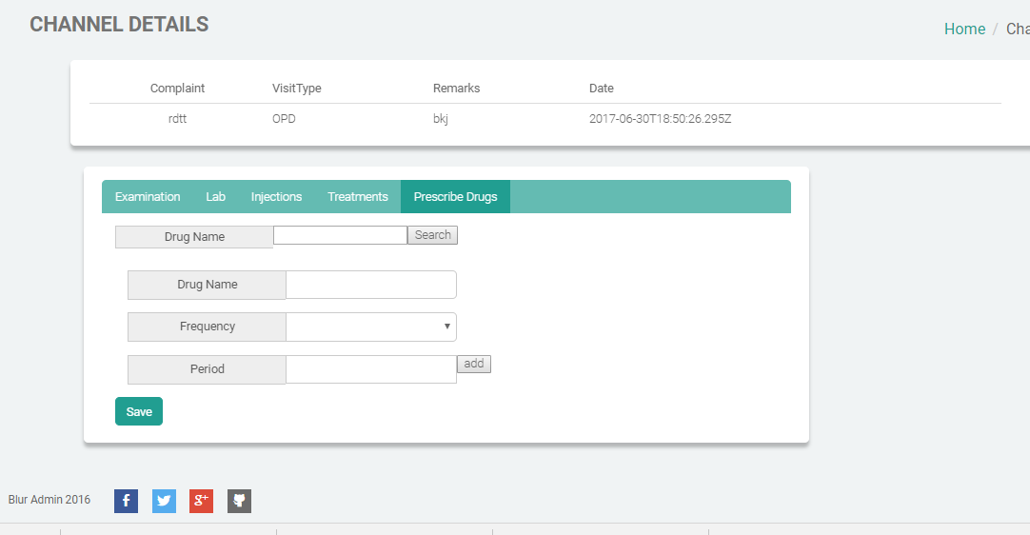
All interfaces are designed in a user friendly manner. Every interface appears with a dash board which provides the user to access their interface easily. The login button to the system contains in the upper right hand corner. After log in to the system with their user name and password, the upper left hand corner changes according to their roll. The dashboard changes according to the patient as well. The upper left hand corner consists with a message box where users can read new messages if they receive any message about contagious patients. Necessary values can be entered through text fields and submitted to the database through buttons. When submitting, if any of the data fields are empty, an appropriate error message is sent. All regular key board short cuts are applicable with this application. This web site consists of bootstrap framework, which provide accessing through any hardware device.

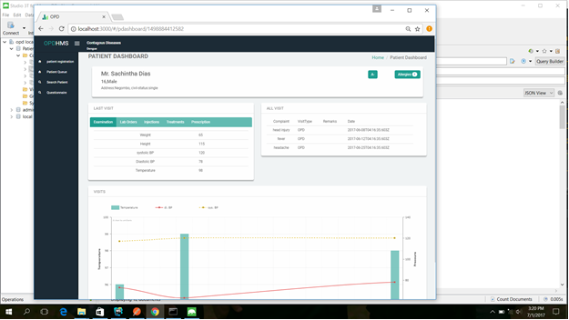

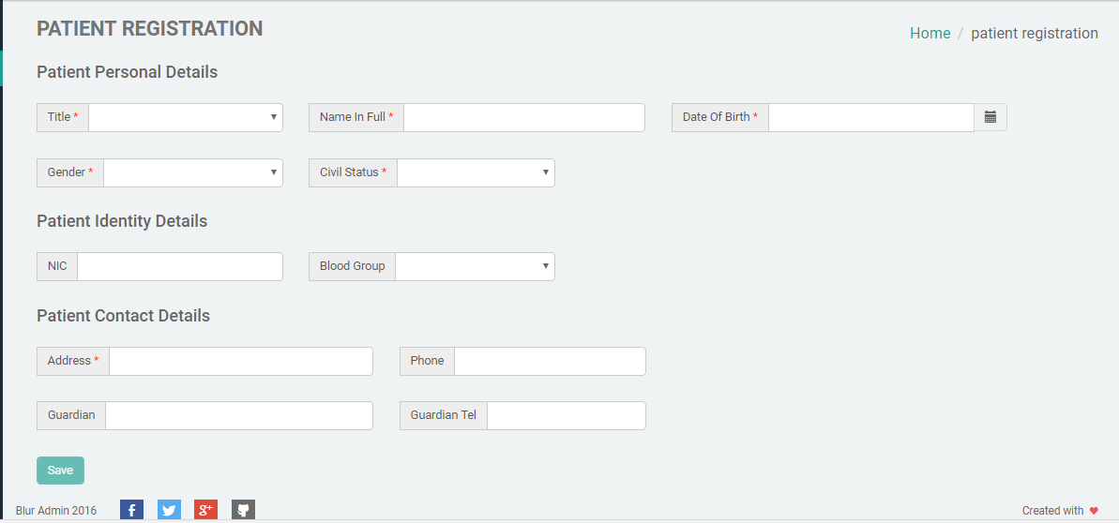

Hardware Interfaces
 | Client Side
 | Processor | RAM |  | Disk Space
Internet Explorer - 6 | All Intel or AMD - 1 GHZ | 256 MB |  | 100 MB
Web cam | 5.0 Megapixel Camera
 | Server Side
 | Processor | RAM |  | Disk Space
 | All Intel or AMD - 2 GHZ | 2 GB |  | 3.5 GB
 | All Intel or AMD - 2 GHZ | 512 MB |  | 500 MB  (Excluding Data Size)

Software Interfaces
- Client on Internet
Web Browser, Operating System (any)

- Web Server
Node.js (open source sever framework), Operating System (any)
Node.js web application framework: ExpressJS

- Database server
MongoDB

- Development End
MEAN stack

Communications Interfaces
Client (system user) on Internet will be using HTTP/HTTPS protocol.

System Features

Use case Diagram

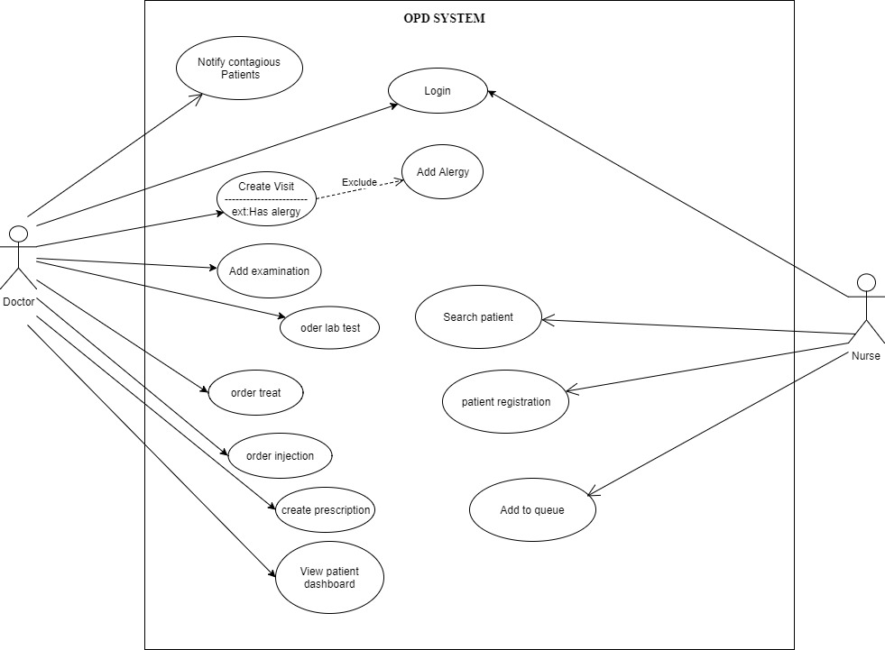

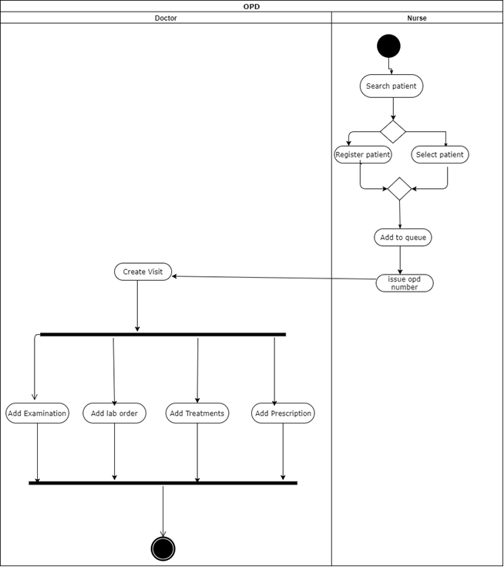
Activity Diagram

Use case Scenarios

Patient registration

Use case Id: 1
Description: Registering a new patient to the system.
Actors : Nurse
Pre-condition: Nurse has an active user account and logged into the system.
Basic Flow: 1.Nurse selects the patient registration link.
2. System displays the patient registration form.
3. Nurse enter the details of the patient.
4. System will issue a token to the patient
5. System prompts the registration confirmation alert.
Alternative Flows: in step #3 if the details of the patient is not given correctly,
The system will pop up the error alerts.
When step 5 , if the nurse is not entered the required details of the patient ,
it will prompt errors.
Post-Condition: A new patient is added to the system.

Search patient

Use case Id: 2
Description: Searching a patient in patient list.
Actors : Nurse
Pre-condition: Nurse should know the patient’s HIN or any other information of the patient..
Basic Flow: 1.Nurse selects the tab “Search patients”.
2. Enter the HIN or any other details of the patient (ex: Name).
3. Particular patient will be shown in the table.
Post-Condition: Searched patient details will be shown in the table.

Add to Queue

Use case Id: 3
Description: Adding patient to the doctor’s queue.
Actors : Nurse
Pre-condition: Nurse has an active user account and logged into the system.
Patient should have been registered.
Basic Flow: 1.Nurse search the patient in registered patient list.
2. Select the patient.
3. Click “Add to queue” button.
Post-Condition: The patient is assigned to the OPD doctor’s queue.

Create visit

Use case Id: 4
Description: Creating a visit for a patient.
Actors : Doctor
Pre-condition: Doctor should be successfully logged into the system.
Patient should be in the queue.
Basic Flow: 1.Doctor selects the patient from the queue.
2. Select “Create Visit”.
3. Doctor adds the visit details.
Post-Condition: The patient’s visit details are recorded

Add Examination

Use case Id: 5
Description: Adding examination to the patient’s visit.
Actors : Doctor
Pre-condition: Doctor should be successfully logged into the system.
Basic Flow: 1.Doctor selects the “Examination” tab.
2. Enter the examination details.
Post-Condition: The patient’s examination is added to the visit.

Prescribe drugs

Use case Id: 6
Description: Prescribing Drugs for the patient.
Actors : Doctor
Pre-condition: Doctor has an active user account and logged into the system.
Patient visit should have been added.
Basic Flow: 1.Doctor selects Prescribe drugs tab.
2. Search the drug on the search bar.
3. Select the drug.
4. Selected drug will be shown under the prescription.
5. After selecting all needed drugs. Generates prescription report.
Additional Flows:
In the step #3 if the doctor select the wrong drug, doctor can remove it from the . Prescription list and can continue flow from step #2.
Post-Condition: Patient prescription is issued.

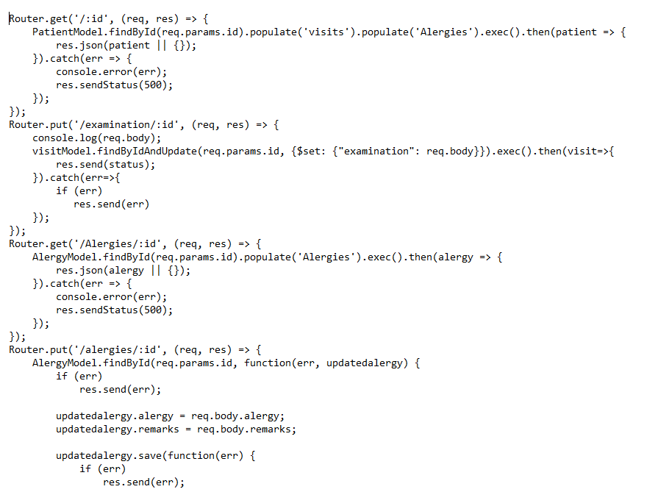
Rest Web Services

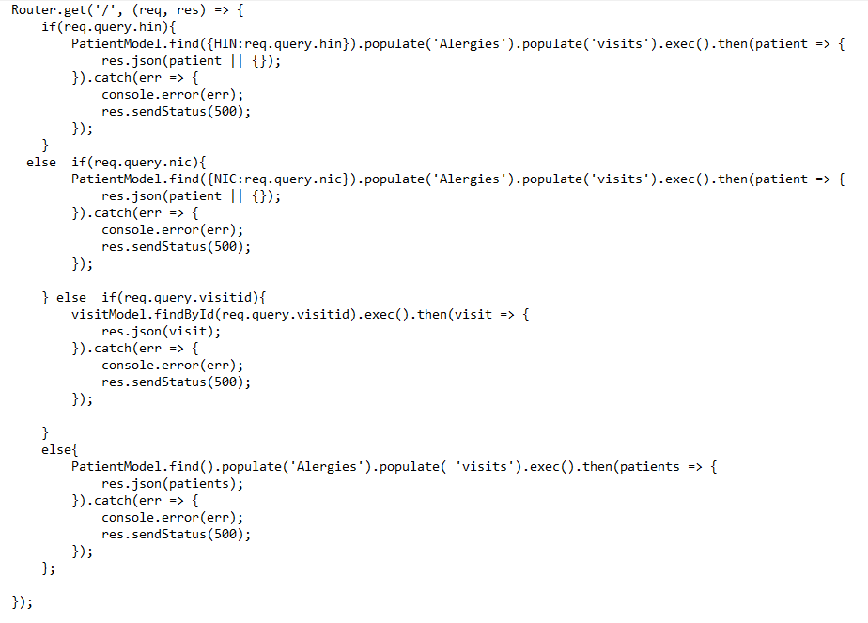

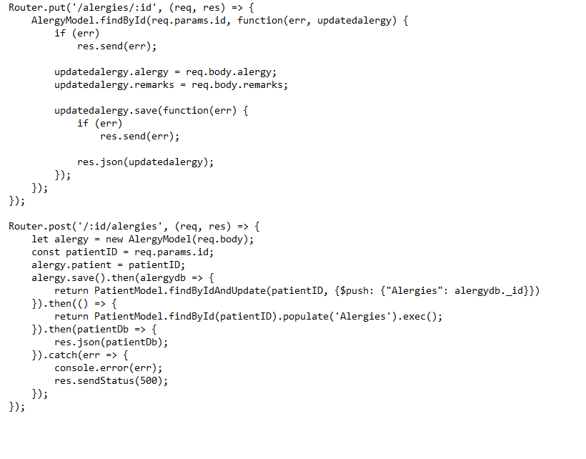

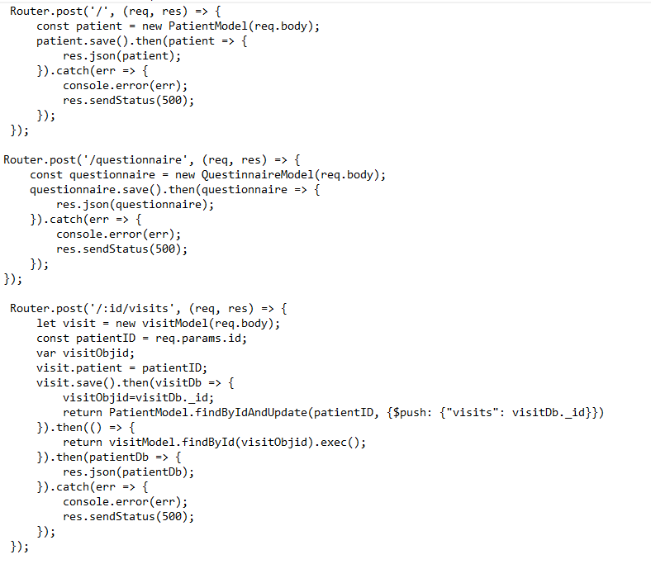

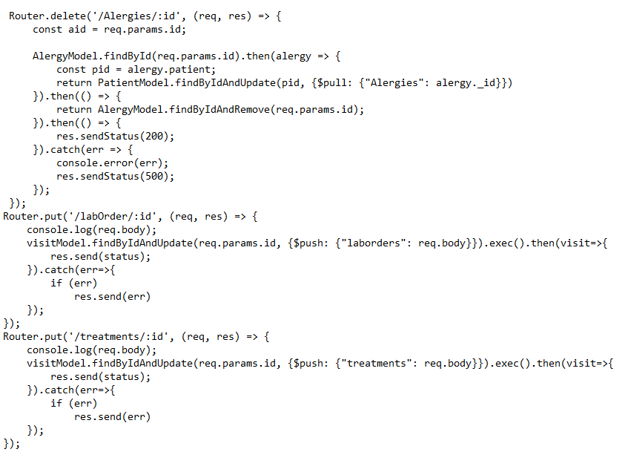
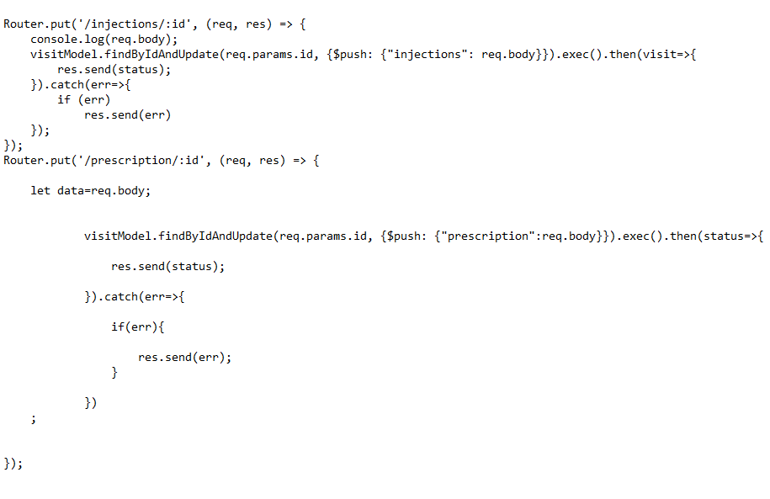

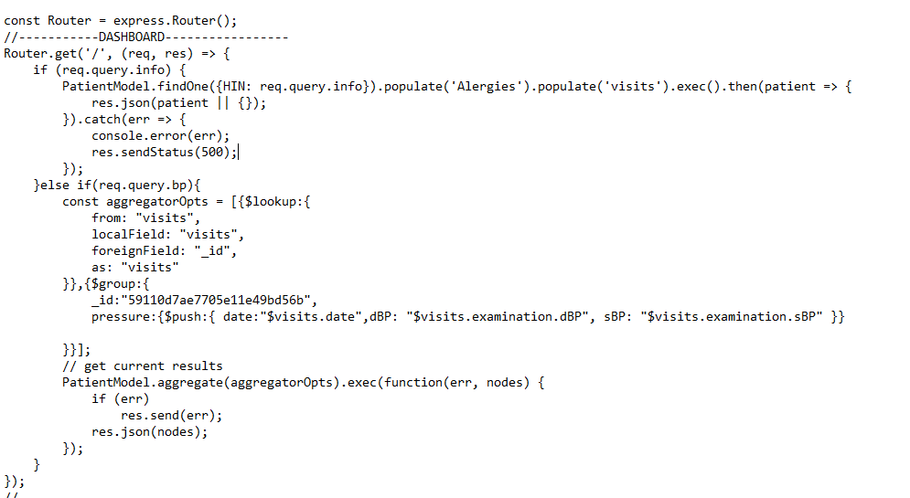

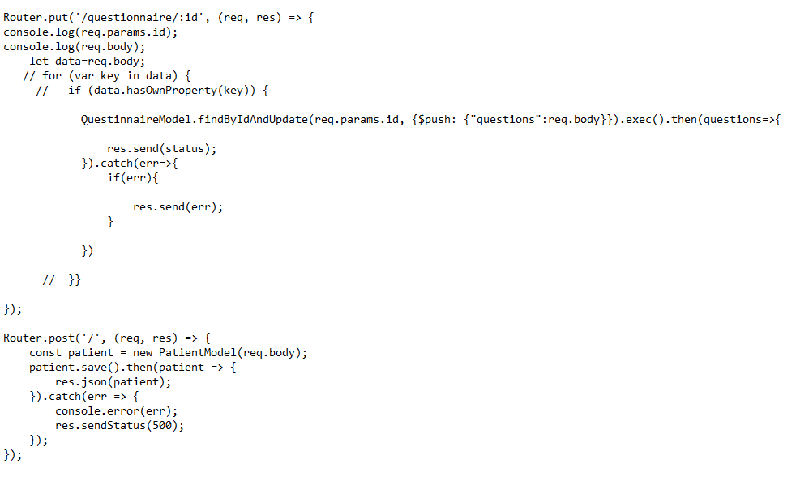

Other Nonfunctional Requirements

Performance Requirements
Performance requirements define acceptable response times for system functionality. The performance of the system will highly depend on the performance of the hardware and software components of the installing computer. When consider about the timing relationships of the system the load time for user interface screens shall take no longer, than two seconds do. It makes fast access to system functions. The login information shall be verified in less than two seconds. Returning query results within two seconds makes searching more accurate.

- Response Time
The system shall give responses in 0.01 second after checking the patient’s information.
- Capacity
The System must support over a million people at a time.
- User-interface
The user-interface screen shall respond within 2 seconds.
- Conformity
The systems must conform to the AWS Accessibility guidelines

Software Quality Attributes

Maintainability

Back Up
The system shall provide the capability to back-up the Data

Errors
The system shall keep a log of all the errors.

Reliability
Availability
The system shall be available all the time

Integrity
How the system would insecure the information in the system and how it avoids the data losses.

Reusability
The ability to use the available components of the system in other systems as well.

Testability
Effort needed to test to ensure the performance of the system.

Usability
How easily a person can take the benefits of the system and the user friendliness.

Appendix A: Analysis Models

High level Architecture
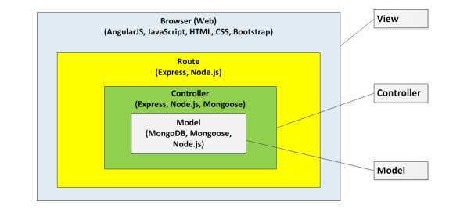

- ER Diagram

